**Interdependence of Spot prices and Future prices -**

**Statistical Analysis using R – Software**

**Arabica variety – Brazil & Honduras major producing country, spot prices compared with New York future prices**

**Brazil**

> library(readxl)

> arabica <- read_excel("F:/python/seminar/arabica.xlsx")

> View(arabica)

> attach(arabica)

> library(fBasics)

> basicStats(data.frame(`brazil sp`,`brazil fp`,`honduras sp`,`honduras fp`))

> options(scipen = 999)

> basicStats(data.frame(`brazil sp`,`brazil fp`,`honduras sp`,`honduras fp`))

> #install.packages("tseries")

> # Install tseries to check ststionary in data

>library(tseries)

> # To test stationarity do ADF test

> adf.test(`brazil sp`)

**Augmented Dickey-Fuller Test**

data: brazil sp

Dickey-Fuller = -4.112, Lag order = 8, p-value = 0.01

alternative hypothesis: stationary

> acf(`brazil sp`)

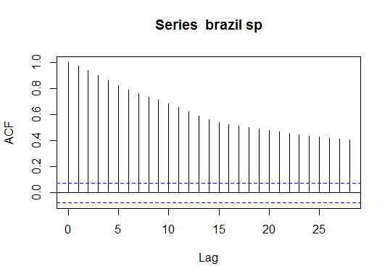

> baz=log(`brazil sp`)

> adf.test(baz)

**Augmented Dickey-Fuller Test**

data: baz

Dickey-Fuller = -3.1791, Lag order = 8, p-value = 0.09153

alternative hypothesis: stationary

> acf(baz)

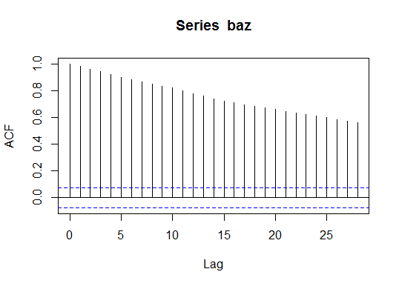

> lbazsp=diff(baz)

> adf.test(lbazsp)

**Augmented Dickey-Fuller Test**

data: lbazsp

Dickey-Fuller = -8.4968, Lag order = 8, p-value = 0.01

alternative hypothesis: stationary

Warning message:

In adf.test(lbazsp) : p-value smaller than printed p-value

> acf(lbazsp)

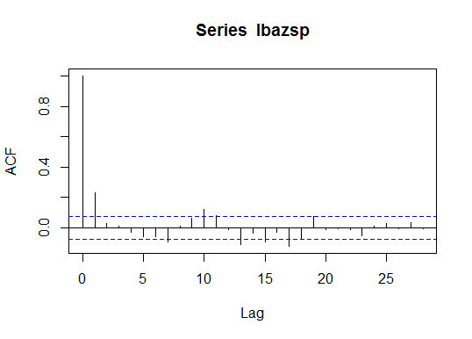

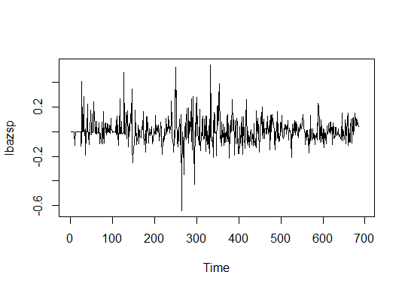

> adf.test(`brazil fp`)

**Augmented Dickey-Fuller Test**

data: brazil fp

Dickey-Fuller = -3.8404, Lag order = 8, p-value = 0.01698

alternative hypothesis: stationary

> acf(`brazil fp`)

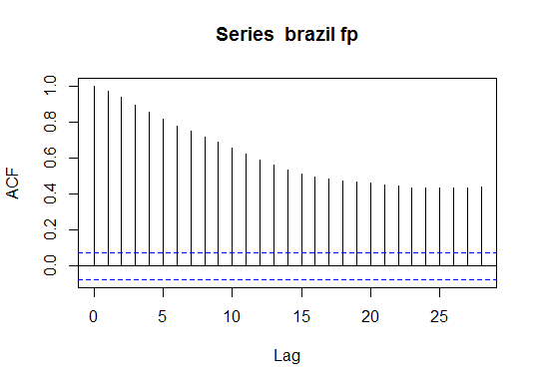

> bazfp=log(`brazil fp`)

> adf.test(bazfp)

**Augmented Dickey-Fuller Test**

data: bazfp

Dickey-Fuller = -2.9496, Lag order = 8, p-value = 0.1764

alternative hypothesis: stationary

> acf(bazfp)

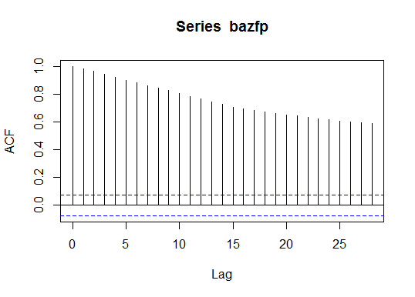

> lbazfp=diff(bazfp)

> adf.test(lbazfp)

**Augmented Dickey-Fuller Test**

data: lbazfp

Dickey-Fuller = -7.6875, Lag order = 8, p-value = 0.01

alternative hypothesis: stationary

Warning message:

In adf.test(lbazfp) : p-value smaller than printed p-value

> acf(lbazfp)

>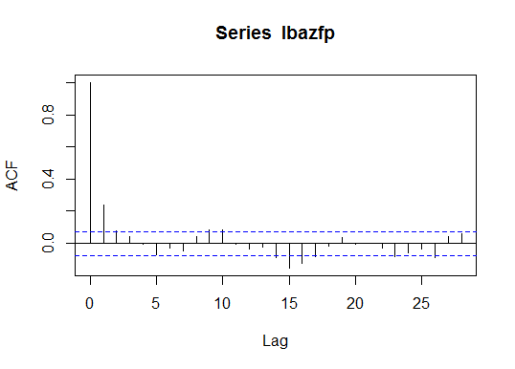

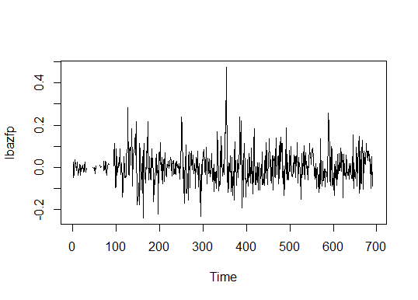

**> #granger causality test**

> # To check optimal lag of variables before GCT

> #install vars package

> library(vars)

> VARselect(data.frame(lbazsp,lbazfp))

$selection

AIC(n) HQ(n) SC(n) FPE(n)

1 1 1 1

$criteria

1 2 3 4 5

AIC(n) -10.43279067787 -10.43252593737 -10.42178414215 -10.41425100969 -10.40796623540

HQ(n) -10.41723277562 -10.40659610028 -10.38548237022 -10.36757730292 -10.35092059380

SC(n) -10.39261355522 -10.36556406629 -10.32803752263 -10.29371964174 -10.26065011902

FPE(n) 0.00002945077 0.00002945858 0.00002977675 0.00003000196 0.00003019119

6 7 8 9 10

AIC(n) -10.39770125990 -10.40450842829 -10.4037111104 -10.39507586480 -10.39320993187

HQ(n) -10.33028368347 -10.32671891701 -10.3155496643 -10.29654248385 -10.28430461609

SC(n) -10.22360039509 -10.20362281504 -10.1760407487 -10.14062075468 -10.11197007332

FPE(n) 0.00003050281 0.00003029603 0.0000303204 0.00003058362 0.00003064106

> grangertest(lbazsp~lbazfp,order = 2,data = arabica)

Granger causality test

Model 1: lbazsp ~ Lags(lbazsp, 1:2) + Lags(lbazfp, 1:2)

Model 2: lbazsp ~ Lags(lbazsp, 1:2)

Res.Df Df F Pr(>F)

1 677

2 679 -2 0.7267 **0.4839**

**P – value is greater than 0.05 significance level. Therefore we accept null hypothesis brazil future price does not granger cause brazil spot prices**

> grangertest(lbazfp~lbazsp,order = 2,data = arabica)

Granger causality test

Model 1: lbazfp ~ Lags(lbazfp, 1:2) + Lags(lbazsp, 1:2)

Model 2: lbazfp ~ Lags(lbazfp, 1:2)

Res.Df Df F Pr(>F)

1 677

2 679 -2 4.7922 0.008577 **

Signif. codes: 0 ‘***’ 0.001 ‘**’ 0.01 ‘*’ 0.05 ‘.’ 0.1 ‘ ’ 1

**P – value is lesser than 0.05 significance level. Therefore we reject null hypothesis thus brazil sp granger cause brazil fp**

**Conclusion = brazil fp does not granger cause brazil spot prices but brazil sp granger cause brazil fp at lag = 2**

> # cointegration analysis

> #jhonson cointegration analysis

> #install "urca"

> library(urca)

> model1=ca.jo(data.frame(lbazsp,lbazfp),ecdet = "const",type = "trace",K=2)

> summary(model1)

######################

# Johansen-Procedure #

######################

Test type: trace statistic, without linear trend and constant in cointegration

Eigenvalues (lambda):

[1] 3.583560e-01 2.626934e-01 1.110223e-16

Values of teststatistic and critical values of test:

test 10pct 5pct 1pct

r <= 1 | 207.84 7.52 9.24 12.97

r = 0 | 510.46 17.85 19.96 24.60

Eigenvectors, normalised to first column:

(These are the cointegration relations)

lbazsp.l2 lbazfp.l2 constant

lbazsp.l2 1.000000000 1.00000000 1.00000

lbazfp.l2 -1.182053005 3.22438228 38.82711

constant -0.001287074 -0.01258943 1058.60296

Weights W:

(This is the loading matrix)

lbazsp.l2 lbazfp.l2 constant

lbazsp.d -0.6453288 -0.2024854 9.213245e-22

lbazfp.d 0.3057287 -0.1608628 3.814231e-22

**conclusion = test value is greater than 5% level of significance. Therefore we reject null hypothesis thus cointegration exists**

**HONDURAS**

> adf.test(`honduras sp`)

Error in adf.test(`honduras sp`) : NAs in x

> hondsp=na.omit(`honduras sp`)

> adf.test(hondsp)

Augmented Dickey-Fuller Test

data: hondsp

Dickey-Fuller = -3.7198, Lag order = 8, p-value = 0.02301

alternative hypothesis: stationary

> acf(hondsp)

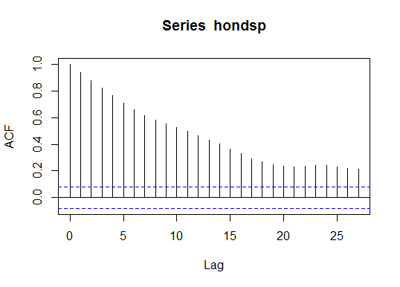

> lhondsp=log(hondsp)

> adf.test(lhondsp)

Augmented Dickey-Fuller Test

data: lhondsp

Dickey-Fuller = -3.571, Lag order = 8, p-value = 0.03548

alternative hypothesis: stationary

> acf(lhondsp)

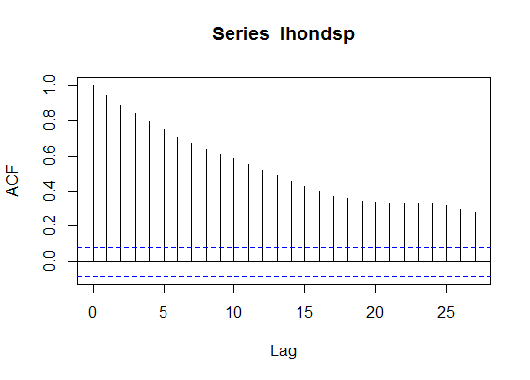

> lhondsp1=diff(lhondsp)

> adf.test(lhondsp1)

Augmented Dickey-Fuller Test

data: lhondsp1

Dickey-Fuller = -9.2637, Lag order = 8, p-value = 0.01

alternative hypothesis: stationary

Warning message:

In adf.test(lhondsp1) : p-value smaller than printed p-value

> acf(lhondsp1)

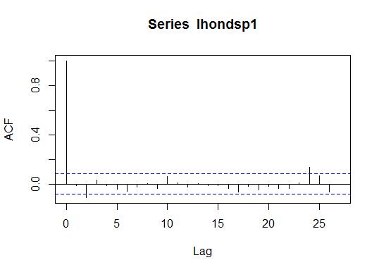

> adf.test(`honduras fp`)

Error in adf.test(`honduras fp`) : NAs in x

> hondfp=na.omit(`honduras fp`)

> adf.test(hondfp)

Augmented Dickey-Fuller Test

data: hondfp

Dickey-Fuller = -4.1757, Lag order = 8, p-value = 0.01

alternative hypothesis: stationary

Warning message:

In adf.test(hondfp) : p-value smaller than printed p-value

> acf(hondfp)

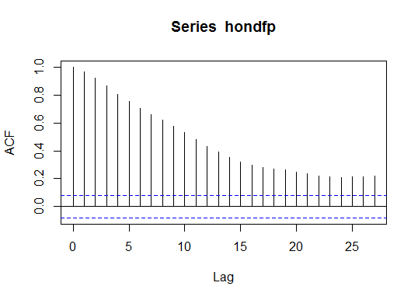

> lhondfp=log(hondfp)

> adf.test(lhondfp)

Augmented Dickey-Fuller Test

data: lhondfp

Dickey-Fuller = -3.6172, Lag order = 8, p-value = 0.03104

alternative hypothesis: stationary

> acf(lhondfp)

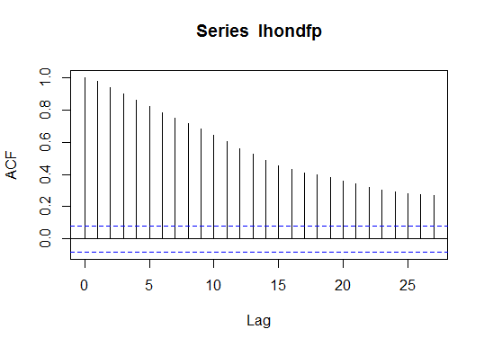

> lhondfp1=diff(lhondfp)

> adf.test(lhondfp1)

Augmented Dickey-Fuller Test

data: lhondfp1

Dickey-Fuller = -7.058, Lag order = 8, p-value = 0.01

alternative hypothesis: stationary

Warning message:

In adf.test(lhondfp1) : p-value smaller than printed p-value

> acf(lhondfp1)

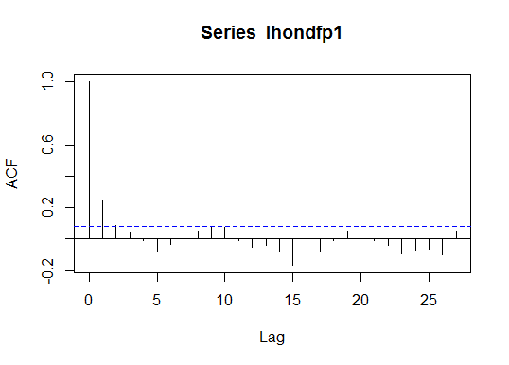

> VARselect(data.frame(lhondsp1,lhondfp1))

$selection

AIC(n) HQ(n) SC(n) FPE(n)

6 3 1 6

$criteria

1 2 3 4 5 6

AIC(n) -9.1315129446 -9.1507501859 -9.168538452 -9.1578787249 -9.1873206389 -9.1997609827

HQ(n) -9.1137160381 -9.1210886750 -9.127012337 -9.1044880053 -9.1220653149 -9.1226410544

SC(n) -9.0858926056 -9.0747162874 -9.062090994 -9.0210177077 -9.0200460623 -9.0020728468

FPE(n) 0.0001082018 0.0001061402 0.000104269 0.0001053868 0.0001023296 0.0001010651

7 8 9 10

AIC(n) -9.1927181725 -9.1955640382 -9.1985931089 -9.191310333

HQ(n) -9.1037336398 -9.0947149012 -9.0858793675 -9.066731987

SC(n) -8.9646164771 -8.9370487835 -8.9096642948 -8.871967960

FPE(n) 0.0001017803 0.0001014922 0.0001011866 0.000101928

> grangertest(lhondsp1~lhondfp1,order = 2,data = arabica)

Granger causality test

Model 1: lhondsp1 ~ Lags(lhondsp1, 1:2) + Lags(lhondfp1, 1:2)

Model 2: lhondsp1 ~ Lags(lhondsp1, 1:2)

Res.Df Df F Pr(>F)

1 575

2 577 -2 38.251 **0.0000000000000002534** ***

---

Signif. codes: 0 ‘***’ 0.001 ‘**’ 0.01 ‘*’ 0.05 ‘.’ 0.1 ‘ ’ 1

**P- value is lesser then 0.05 significance level. Therefore we reject null hypothesis thus Honduras future prices granger cause Honduras spot prices**

> grangertest(lhondfp1~lhondsp1,order = 2,data = arabica)

Granger causality test

Model 1: lhondfp1 ~ Lags(lhondfp1, 1:2) + Lags(lhondsp1, 1:2)

Model 2: lhondfp1 ~ Lags(lhondfp1, 1:2)

Res.Df Df F Pr(>F)

1 575

2 577 -2 2.7519 **0.06465** .

Signif. codes: 0 ‘***’ 0.001 ‘**’ 0.01 ‘*’ 0.05 ‘.’ 0.1 ‘ ’ 1

**P- value is greater then 0.05 significance level. Therefore we accept null hypothesis thus Honduras spot prices does not granger cause Honduras future prices**

**Outcome = Honduras fp granger causes Honduras sp but Honduras sp does not cause Honduras fp at lag = 2**

> model2=ca.jo(data.frame(lhondsp1,lhondfp1),ecdet = "const",type = "trace",K=2)

> summary(model2)

######################

# Johansen-Procedure #

######################

Test type: trace statistic , without linear trend and constant in cointegration

Eigenvalues (lambda):

[1] 0.4392427278950527536061 0.2679296303722684680082 0.0000000000000001665335

Values of teststatistic and critical values of test:

Test 10pct 5pct 1pct

r <= 1 | 180.89 7.52 9.24 12.97

r = 0 | **516.40** 17.85 **19.96** 24.60

Eigenvectors, normalised to first column:

(These are the cointegration relations)

lhondsp1.l2 lhondfp1.l2 constant

lhondsp1.l2 1.000000000 1.0000000 1.000000

lhondfp1.l2 -0.816239328 49.0030179 6.022548

constant -0.001011105 -0.0850832 74.300543

Weights W:

(This is the loading matrix)

lhondsp1.l2 lhondfp1.l2 constant

lhondsp1.d -1.31159632 -0.004858001 -0.0000000000000000000044405595

lhondfp1.d -0.05458155 -0.014870911 -0.0000000000000000000001555768

**Conclusion = Test value is greater than 5% significance level. We reject null hypothesis thus cointegration exists**

**Robusta variety = India & Uganda major producing country, spot prices compared with London future prices**

**India-**

> library(readxl)

> robusta <- read_excel("F:/python/seminar/robusta.xlsx")

New names:

* `year` -> `year...2`

* `year` -> `year...6`

> View(robusta)

> attach(robusta)

The following objects are masked from arabica:

year...2, year...6

> library(fBasics)

> basicStats(data.frame(`India sp`,`India fp`,`Uganda sp`,`Uganda fp`))

> options(scipen = 999)

> basicStats(data.frame(`India sp`,`India fp`,`Uganda sp`,`Uganda fp`))

> library(tseries)

> adf.test(`India sp`)

Error in adf.test(`India sp`) : NAs in x

> ind=na.omit(`India sp`)

> adf.test(ind)

Augmented Dickey-Fuller Test

data: ind

Dickey-Fuller = -2.7568, Lag order = 7, p-value = 0.2577

alternative hypothesis: stationary

> lind=log(ind)

> adf.test(lind)

Augmented Dickey-Fuller Test

data: lind

Dickey-Fuller = -2.3088, Lag order = 7, p-value = 0.447

alternative hypothesis: stationary

> lindsp1=diff(lind)

> adf.test(lindsp1)

Augmented Dickey-Fuller Test

data: lindsp1

Dickey-Fuller = -6.9196, Lag order = 7, p-value = 0.01

alternative hypothesis: stationary

Warning message:

In adf.test(lindsp1) : p-value smaller than printed p-value

> acf(lindsp1)

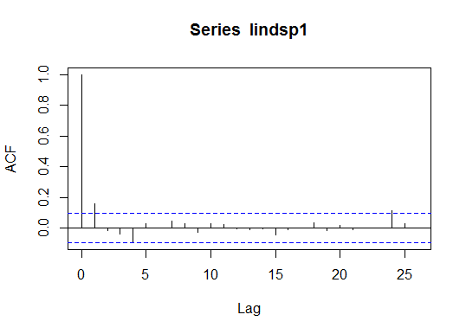

> adf.test(`India fp`)

Error in adf.test(`India fp`) : NAs in x

> indfp=na.omit(`India fp`)

> adf.test(indfp)

Augmented Dickey-Fuller Test

data: indfp

Dickey-Fuller = -3.2443, Lag order = 7, p-value = 0.0805

alternative hypothesis: stationary

> acf(indfp)

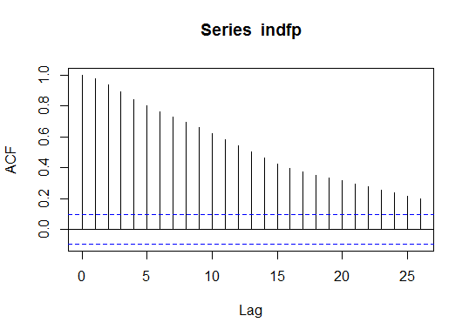

> lindfp=log(indfp)

> adf.test(lindfp)

Augmented Dickey-Fuller Test

data: lindfp

Dickey-Fuller = -2.6119, Lag order = 7, p-value = 0.3189

alternative hypothesis: stationary

> lindfp1=diff(lindfp)

> adf.test(lindfp1)

Augmented Dickey-Fuller Test

data: lindfp1

Dickey-Fuller = -6.2222, Lag order = 7, p-value = 0.01

alternative hypothesis: stationary

Warning message:

In adf.test(lindfp1) : p-value smaller than printed p-value

> acf(lindfp1)

> 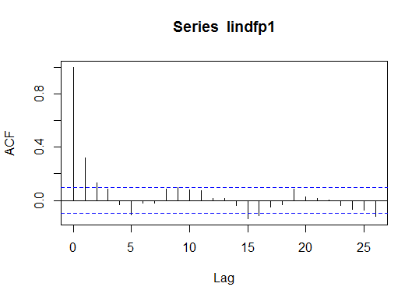

>

> library(vars)

> VARselect(data.frame(lindsp1,lindfp1))

$selection

AIC(n) HQ(n) SC(n) FPE(n)

4 1 1 4

$criteria

1 2 3 4 5

AIC(n) -10.87265723375 -10.85929818870 -10.87018179644 -10.8734511963 -10.87220650946

HQ(n) -10.84958299609 -10.82084112594 -10.81634190858 -10.8042284834 -10.78760097139

SC(n) -10.81431135007 -10.76205504923 -10.73404140119 -10.6984135453 -10.65827160264

FPE(n) 0.00001896991 0.00001922506 0.00001901704 0.0000189551 0.00001897892

6 7 8 9 10

AIC(n) -10.85951007606 -10.8575178982 -10.8522853785 -10.86445462959 -10.84646473971

HQ(n) -10.75952171289 -10.7421467100 -10.7215313651 -10.71831779110 -10.68494507612

SC(n) -10.60667791346 -10.5657884798 -10.5216587043 -10.49493069963 -10.43804355396

FPE(n) 0.00001922174 0.0000192605 0.0000193621 0.00001912861 0.00001947672

> library(lmtest)

> grangertest(lindsp1~lindfp1,order = 2,data = robusta)

Granger causality test

Model 1: lindsp1 ~ Lags(lindsp1, 1:2) + Lags(lindfp1, 1:2)

Model 2: lindsp1 ~ Lags(lindsp1, 1:2)

Res.Df Df F Pr(>F)

1 417

2 419 -2 9.9608 **0.00005946** ***

---

Signif. codes: 0 ‘***’ 0.001 ‘**’ 0.01 ‘*’ 0.05 ‘.’ 0.1 ‘ ’ 1

**P – value is lesser than 0.05 significance level. We reject null hypothesis thus India fp granger cause India sp**

> grangertest(lindfp1~lindsp1,order = 2,data = robusta)

Granger causality test

Model 1: lindfp1 ~ Lags(lindfp1, 1:2) + Lags(lindsp1, 1:2)

Model 2: lindfp1 ~ Lags(lindfp1, 1:2)

Res.Df Df F Pr(>F)

1 417

2 419 -2 0.0214 **0.9788**

**P – value is greater than 0.05 significance level .we accept null hypothesis thus India sp does to granger cause India fp**

**Conclusion = India fp granger cause India sp but India sp does not granger cause India fp at lag = 2**

>

> library(urca)

> model1=ca.jo(data.frame(lindsp1,lindfp1),ecdet = "const",type = "trace",K=2)

> summary(model1)

######################

# Johansen-Procedure #

######################

Test type: trace statistic , without linear trend and constant in cointegration

Eigenvalues (lambda):

[1] 0.34652136745828043817852 0.24771361471702016410212 0.00000000000000005551115

Values of teststatistic and critical values of test:

test 10pct 5pct 1pct

r <= 1 | 120.12 7.52 9.24 12.97

r = 0 | **299.66** 17.85 **19.96** 24.60

Eigenvectors, normalised to first column:

(These are the cointegration relations)

lindsp1.l2 lindfp1.l2 constant

lindsp1.l2 1.0000000000 1.00000000 1.00000

lindfp1.l2 -0.5315057796 5.05592344 -11.73233

constant -0.0005653061 0.01244552 45.88795

Weights W:

(This is the loading matrix)

lindsp1.l2 lindfp1.l2 constant

lindsp1.d -0.9270574 -0.04966862 -0.000000000000000000003214222

lindfp1.d 0.1100580 -0.11916648 0.000000000000000000005101638

**Conclusion = Test value is greater than 5% significance level. Therefore we reject null hypothesis thus cointegration exists**

**Uganda**

> adf.test(`Uganda sp`)

Augmented Dickey-Fuller Test

data: Uganda sp

Dickey-Fuller = -3.2093, Lag order = 8, p-value = 0.08632

alternative hypothesis: stationary

> acf(`Uganda sp`)

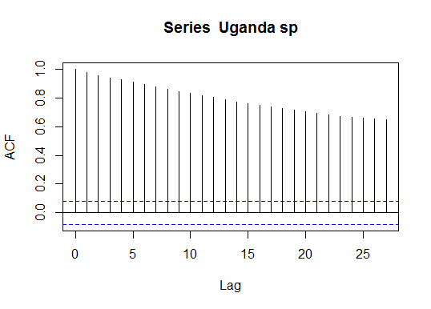

> ugasp=log(`Uganda sp`)

> adf.test(ugasp)

Augmented Dickey-Fuller Test

data: ugasp

Dickey-Fuller = -3.0505, Lag order = 8, p-value = 0.1336

alternative hypothesis: stationary

> acf(ugasp)

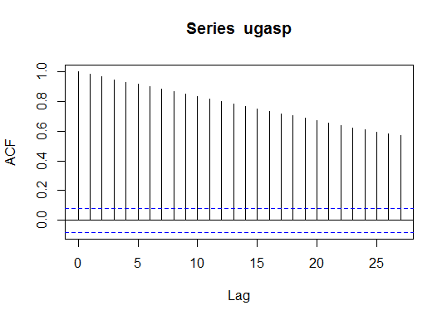

> lugasp=diff(ugasp)

> adf.test(lugasp)

Augmented Dickey-Fuller Test

data: lugasp

Dickey-Fuller = -7.5767, Lag order = 8, p-value = 0.01

alternative hypothesis: stationary

Warning message:

In adf.test(lugasp) : p-value smaller than printed p-value

> acf(lugasp)

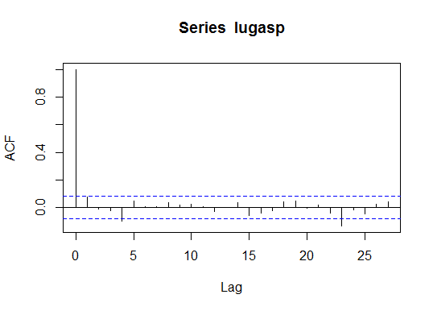

> adf.test(`Uganda fp`)

Augmented Dickey-Fuller Test

data: Uganda fp

Dickey-Fuller = -3.6226, Lag order = 8, p-value = 0.03052

alternative hypothesis: stationary

> acf(`Uganda fp`)

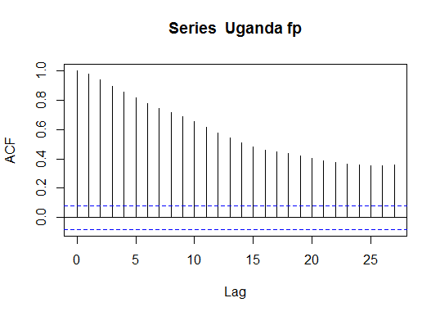

> ugafp=log(`Uganda fp`)

> adf.test(ugafp)

Augmented Dickey-Fuller Test

data: ugafp

Dickey-Fuller = -2.8921, Lag order = 8, p-value = 0.2007

alternative hypothesis: stationary

> lugafp=diff(ugafp)

> adf.test(lugafp)

Augmented Dickey-Fuller Test

data: lugafp

Dickey-Fuller = -6.364, Lag order = 8, p-value = 0.01

alternative hypothesis: stationary

Warning message:

In adf.test(lugafp) : p-value smaller than printed p-value

> acf(lugafp)

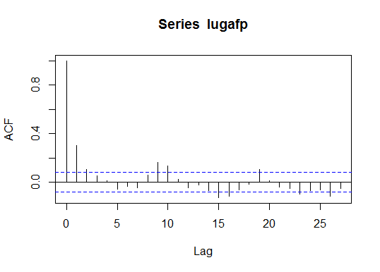

> VARselect(data.frame(lugasp,lugafp))

$selection

AIC(n) HQ(n) SC(n) FPE(n)

1 1 1 1

$criteria

1 2 3 4 5

AIC(n) -9.58928415824 -9.57985064448 -9.57604463061 -9.57958401928 -9.5770965399

HQ(n) -9.57163790135 -9.55044021634 -9.53487003121 -9.52664524862 -9.5123935980

SC(n) -9.54402906618 -9.50442549104 -9.47044941580 -9.44381874309 -9.4111612024

FPE(n) 0.00006845842 0.00006910733 0.00006937096 0.00006912604 0.0000692985

6 7 8 9 10

AIC(n) -9.57883087462 -9.56701517412 -9.56711714359 -9.57819915341 -9.57201528149

HQ(n) -9.50236376145 -9.47878388969 -9.46712168791 -9.46643952647 -9.44849148329

SC(n) -9.38272547568 -9.34073971381 -9.31067162191 -9.29158357035 -9.25522963705

FPE(n) 0.00006917883 0.00007000164 0.00006999525 0.00006922477 0.00006965533

> grangertest(lugasp~lugafp,order = 3,data = robusta)

Granger causality test

Model 1: lugasp ~ Lags(lugasp, 1:3) + Lags(lugafp, 1:3)

Model 2: lugasp ~ Lags(lugasp, 1:3)

Res.Df Df F Pr(>F)

1 578

2 581 -3 6.7338 **0.0001803** ***

Signif. codes: 0 ‘***’ 0.001 ‘**’ 0.01 ‘*’ 0.05 ‘.’ 0.1 ‘ ’ 1

**P – value less than 0.05 significance level. We reject null hypothesis thus Uganda fp granger cause Uganda sp**

> grangertest(lugafp~lugasp,order = 3,data = robusta)

Granger causality test

Model 1: lugafp ~ Lags(lugafp, 1:3) + Lags(lugasp, 1:3)

Model 2: lugafp ~ Lags(lugafp, 1:3)

Res.Df Df F Pr(>F)

1 578

2 581 -3 0.7387 **0.5292**

**P – value greater than 0.05 significance level. we accept null hypothesis thus Uganda sp does not cause Uganda fp**

**Conclusion = Uganda fp granger cause Uganda sp but Uganda sp does not granger cause Uganda fp**

>

> model2=ca.jo(data.frame(lugasp,lugafp),ecdet = "const",type = "trace",K=3)

> summary(model2)

######################

# Johansen-Procedure #

######################

Test type: trace statistic , without linear trend and constant in cointegration

Eigenvalues (lambda):

[1] 0.29651365011250629954986 0.18534748604799455851122 0.00000000000000005551115

Values of teststatistic and critical values of test:

test 10pct 5pct 1pct

r <= 1 | 119.92 7.52 9.24 12.97

r = 0 | **325.67** 17.85 **19.96** 24.60

Eigenvectors, normalised to first column:

(These are the cointegration relations)

lugasp.l3 lugafp.l3 constant

lugasp.l3 1.000000000 1.000000000 1.0000000

lugafp.l3 -0.897259671 3.619355787 -0.3807542

constant -0.002992645 -0.009132585 13.0242800

Weights W:

(This is the loading matrix)

lugasp.l3 lugafp.l3 constant

lugasp.d -0.9498057 -0.1225131 0.00000000000000000002902871

lugafp.d 0.1966473 -0.1434311 -0.00000000000000000002303578

**Conclusion = test value is greater than 5% significance level. Therefore we reject null hypothesis thus cointegration exists**